Artificial light sources as light pollutant of humans melatonin suppression
Piotr Jakubowski
Bialystok University of Technology, Faculty of Electrical Engineering, Wiejska 45d, 15-351Bialystok
Received August 14, 2019; revised December 2, 2008; accepted December 4, 2008; published December 5, 2008
Abstract—Blue light emitted by LEDs might influence on natural biological rhythm of human being, what can be considered as environment pollution. In this paper the effect of the latest commercially available LEDs on melatonin suppression index (MSI) was analyzed. Research was done based on spectral power distribution of given LED (SPD) and melatonin suppression function in reference to melatonin suppression under daylight (illuminant D65). Results of calculations shows strong correlation between CCT and MSI, however MSI factor might vary for different LEDs with same CCT.

In recent years we could observe a rapid development of LED technology. In result, conventional light sources have been replaced in most lighting applications today. Lifetime and efficiency of LEDs were the main driver for this change. Contemporary LEDs can offer efficiency above 200 lm/W and lifetime exceeding 50 000 hour. Nevertheless, further efficiency improvement is difficult to achieve, as we’re getting closer and closer to theoretical limits [1]. On the other hand, lifetime is satisfactory for most of applications of general lighting. For these reasons, LED manufacturers are searching for other ideas to improve their products. Improvements in light quality is currently the most promising way of further LEDs development. In particular, wellbeing is a key aspect of every modern lighting installation [2]-[3]. It was proven [4]-[5], that blue light creates not only visual sensation, but can also influence biological rhythm of the body, so called circadian cycle. The mechanism was created by thousands years of evolution and have strong influence on our comfort, concentration and alertness. On the other hand, disorders of this cycle might lead to serious disease. Blue light might also cause immediate eye damage, but this mechanism is independent from topic discussed in this paper [6]. For these reasons, high amount blue light is considered as environment pollution. White LEDs are called: blue rich light sources, i.e. contain significant amount of radiated power in range between (400÷500) nm. Light in this range is responsible for stimulation intrinsically photosensitive retinal ganglion cells (so called ip-RGC [7]). This information is utilized by brain for melatonin secretion. Finally, melatonin concentration in blood is determining phases of human activity and sleep.
There are few ways to quote and measure potential influence of given light source on human body in respect to blue light exposition [8]-[11]. Melatonin suppression index (MSI) was one of the first commonly used factor for describing the phenomena. It is relating spectral power distribution of given light source S_{lamp}(λ) to experimentally measured melatonin suppression function M(λ) and daylight radiation as illuminant D65(λ) (see formula 1 and Fig. 1).

$MSI=\frac{\int_{380}^{730}{S_{lamp}(λ)⋅M(λ)}}{\int_{380}^{730}{M(λ)⋅D65(λ)}}$ (1)

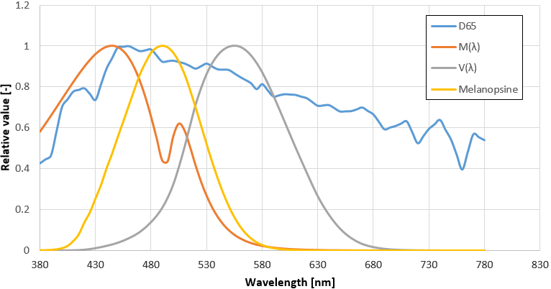
Fig. 1. Spectral power distribution of illuminant D65, melatonin suppression function and human eye sensitivity
As much as MSI is well accepted index, CIE in their latest publications recommends to use the most primary response of human body for blue light stimulation [12]. Melanopic sensitivity curve, represents response of photo pigment, which is contained in ipRGC (see Fig. 1). Formula 2 convolves melanopic irradiance (E_{mel}) with SPD of light source S(λ), then multiplied by relevant constant K_{N}. Result should be expressed in radiometric units with relevant comment about weighting function (in this case: melanopic fux or melanopic irradiance).

$E_{e,α}=\int_{380}^{780}{E_{Mel}\left(λ\right)⋅S\left(λ\right)d\left(λ\right)}$ (2)
The typical spectral power distributions SPDs for representative LEDs of given correlated color temperature CCT were presented on Fig. 2, and their colorimetric parameters are described in Table 1 and Table 2.

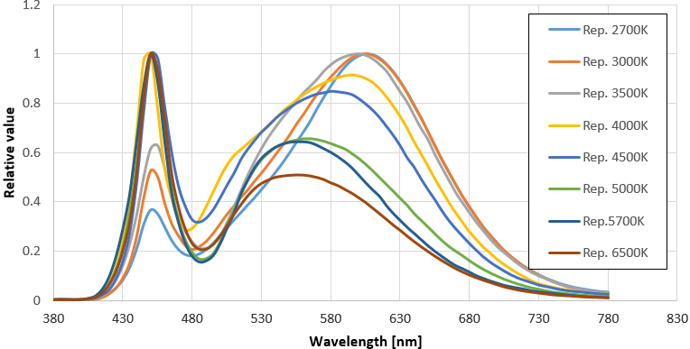
Fig. 2. The SPDs of standard white representative LEDs
Table 1. The colorimetric parameters of typical LEDs presented in the market
SPD | Typical LEDs
CCT | 2700K | 3000K | 3500K | 4000K
x | 0.4546 | 0.4353 | 0.4171 | 0.3754
y | 0.4085 | 0.4018 | 0.3961 | 0.3728
u’ | 0.2600 | 0.2504 | 0.2411 | 0.2234
v’ | 0.5257 | 0.5203 | 0.5152 | 0.4991
CRI | 81 | 83 | 80 | 84
Table 2. The colorimetric parameters of typical LEDs presented in the market
SPD | Typical LEDs
CCT | 4500K | 5000K | 5700K | 6500K
x | 0.3634 | 0.3424 | 0.3271 | 0.3113
y | 0.3703 | 0.3514 | 0.3457 | 0.3237
u’ | 0.2164 | 0.2097 | 0.2014 | 0.1988
v’ | 0.4962 | 0.4842 | 0.4791 | 0.4653
CRI | 82 | 76 | 72 | 80

However, LED technology and phosphor compositions bring a wide range of possibilities to create any required spectral power distribution of white light. For that reason there is theoretically unlimited number of ways to create white light. For example, warm white light might be created with use of different blue emitters and phosphor compositions (see Fig. 3 and Table 3).

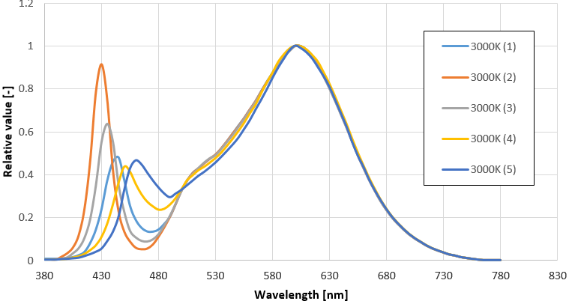
Fig. 3. Different SPDs of warm white LEDs (3000K)
Table 3. The colorimetric parameters of LEDs with CCT=3000 K and different SPDs
CCT | LED with CCT=3000K
Sample | 1 | 2 | 3 | 4 | 5
x | 0.4371 | 0.4317 | 0.4347 | 0.4354 | 0.4349
y | 0.4047 | 0.3934 | 0.3996 | 0.4012 | 0.4002
u’ | 0.2504 | 0.2518 | 0.2511 | 0.2508 | 0.2509
v’ | 0.5217 | 0.5163 | 0.5193 | 0.5200 | 0.2509
CRI | 80 | 78 | 79 | 81 | 82

There are also commercially available LEDs which mimic sun radiation in visible range (see Table 4 and Fig. 4). Their SPD is very different from typical LEDs, what improves colour perception and according to marketing materials, amount of blue light is more closer to natural light. However, it was all achieved by cost of efficiency, which is significantly lower than in case of standard LEDs.

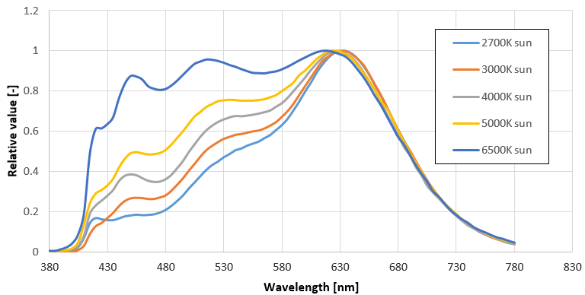
Fig. 4. The SPDs of LEDs which mimic sun light radiation in visible range
Table 4. The colorimetric parameters of “sun type” LEDs
SPD | „sun - type” LEDs
Sample | 2700K | 3000K | 3500K | 4000K | 5000K | 6500K
x | 0.4587 | 0.4372 | 0.4121 | 0.3911 | 0.3475 | 0.3146
y | 0.4089 | 0.4060 | 0.3946 | 0.3868 | 0.3545 | 0.3287
u’ | 0.2625 | 0.2499 | 0.2385 | 0.2280 | 0.2119 | 0.1993
v’ | 0.5265 | 0.5222 | 0.5139 | 0.5075 | 0.4864 | 0.4684
CRI | 97 | 97 | 97 | 98 | 97 | 96

Contemporary, conception of human centric lighting become more and more popular. The idea is based on “tailored light”, which is adequate to specific time of the day. The goal of this, is to make artificial light the most similar to the sunlight and keep natural biological rhythm of the day. On the other hand, such a dynamic light might be supportive to boost alertness and concertation when needed or help in relaxation and falling sleep to support fast recovery. Thus, stimulation by light is an integral point of this idea. For that reason, special LEDs with increased radiation around 480 nm were developed (see Fig. 5 and Table 5). In this case, additional light radiated around maximum of melanopsine sensitivity will influence on melatonin secretion. Such light will improve alertness and might be perceived as energizing. Nevertheless, it is important to mention that irresponsible use of such light might bring negative effect on human body.
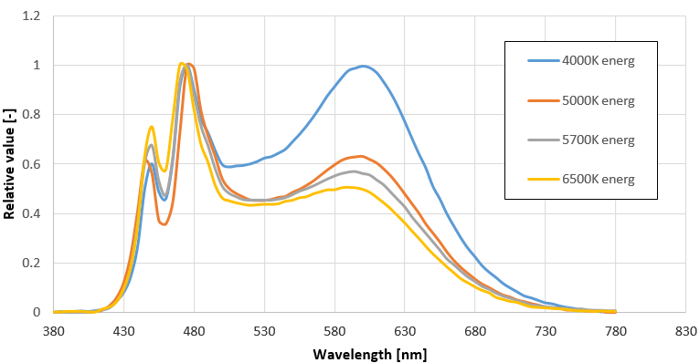
Fig. 5. The SPDs of “LEDs with additional blue light radiation in range of maximum of melatopsine sensitivity (energizing)
Table 5. The colorimetric parameters of “energizing type” LEDs
SPD | „Energizing - type”
CCT | 4000K | 5000K | 5700K | 6500K
x | 0.3821 | 0.3430 | 0.3267 | 0.3112
y | 0.3816 | 0.3532 | 0.3402 | 0.3253
u’ | 0.2243 | 0.2094 | 0.2033 | 0.1981
v’ | 0.5039 | 0.4851 | 0.4762 | 0.4661
CRI | 84 | 84 | 84 | 84

To compare circadian stimulus of different LEDs, their luminous flux was normalized to same level and then MSI factor was calculated and analyzed. There is clear relation between correlated color temperature of given LED (CCT) and its MSI parameter. The colder light is, the higher MSI is expected (see Fig. 6). In case of LEDs with additional blue light content (energizing), MSI might be increased by (2÷8)% on top of standard LEDs. On the other hand, LEDs with SPD similar to sun light might bring significantly higher MSI (even 14% above standard LED with high CCTs). This trend is also relevant for lower CCTs (warm light). The lowest MSI is expected from standard LEDs, so this kind of light might the most useful for relax and it is less sleep disturbing.

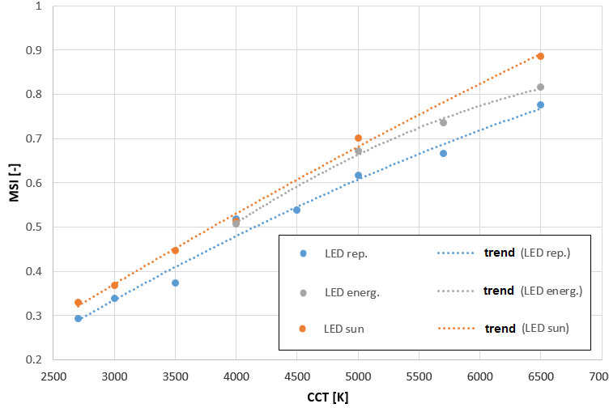
Fig. 6. MSI for different white LED technology across CCT
Analysis of LEDs with same CCT, but different SPD shows a big differences in MSI parameter (see Fig. 7). There is 23% gap between sample 1 and 2, what brings a clear conclusion that CCT of a light source, even in the same technology, cannot be associated with melatonin secretion or influence on biological rhythm.
Blue light shouldn’t be considered as a tread only. In fact it occurs in nature in high amount. Nevertheless, over exposition on this stimulus in wrong timing is not recommended. The only way to control blue light pollution from artificial light sources is to limit it at application level. Thus, special attention should be taken while choosing optimal light sources for given luminaire.

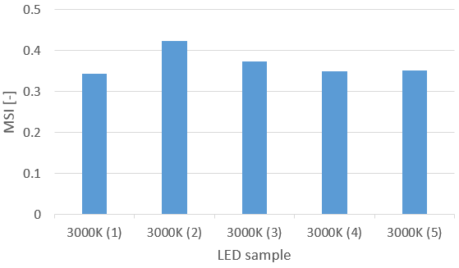
Fig. 7. The MSI values for LEDs having the same CCT=3000K but different SPD
References

- C. C. Sun, et al., Packaging efficiency in phosphor-converted white LEDs and its impact to the limit of luminous efficacy, Journal of Solid State Lighting, 1:19, (2014).
- M. S. Rea, M. G. Figueiro, J. D. Bullough, “Circadian photobiology: An emerging framework for lighting practice and research”, Light Research Technology Vol. 34(3), (2002).
- I. Fryc, P. Jakubowski, K. Kołacz, Analysis of optical radiation parameters of compact discharge HID lamps and LED COB modules used for illuminating shop windows, Przeglad Elektrotechniczny, R. 93, No. 11, (2017).
- G. C. Brainard, J. P. Hanifin, J.M. Greeson, B. Byrne, E. Gerner, D. D. Rollang, “Action spectrum for melatonin regulation in humans: evidence for a novel circadian photoreceptor”, Journal of Neuroscience vol. 21, (2001).
- K. Thapan, J. Arendt, D. J. Skene, “An action spectrum for melatonin supression: evidence for a novel non-rod, non-cone photoreceptor system in humans,” Journal of Physiology vol. 535, (2001).
- I. Fryc, J. Fryc, P. Jakubowski, K. A. Wąsowski, Technical, medical and legal aspects of domestic light sources photobiological safety, Przeglad Elektrotechniczny, R. 93, No. 3, (2017).
- J. Enzi et. al, A “Melanopic” Spectral Efficiency Function Predicts the Sensitivity of Melanopsin Photoreceptors to Polychromatic Lights Journal of biological rhytms, Vol. 26 No. 4, (2011).
- M. Aube, J. Roby J, M. Kocifaj, Evaluating Potential Spectral Impacts of Various Artificial Lights on Melatonin Suppression, Photosynthesis, and Star Visibility. PLOS ONE, Vol. 8, (2013).
- P. Jakubowski, I. Fryc, Metrological requirements for measurements of circadian radiation, Optica Applicata, Vol. 48 Issue 4, (2018).
- P. Jakubowski, I. Fryc, Measurement methods of optical radiation in circadian active range, Zeszyty Naukowe Wydziału Elektrotechniki i Automatyki Politechniki Gdańskiej, nr 54 (2017).
- P. Jakubowski, Comparative analysis of light parameters of LEDs and OLEDs in context of blue light emission, Polish Journal for Sustainable Development 21 (2), (2017).
- CIE TN003:2015, “Report on the First International Workshop on Circadian and neurophysiological Photometry”, (2015).

E-mail: piotr.7akubowski@gmai.com

