Abstract—Breast phantom made as combination of paraffin and INTRALIPIDTM was tested by use of conventional X-ray computed tomography and polarimetric optical tomography. The INTRALIPIDTM is a liquid commonly used for simulation breast tissues optical properties but it is useless as X-ray phantom. During our tests we have observed that X-ray tomography allows to reconstruct correctly the positions of INTRALIPIDTM inclusions inside paraffin medium but we cannot distinguish different densities of INTRALIPIDTM in each inclusion. On the other hand the polarimetric optical tomography allows to distinguish densities of INTRALIPIDTM (0%, 10%, 20%) in inclusions but with relatively low accuracy of their position.

Breast phantom for comparison X-ray
and polarimetric optical tomography imaging

P. K. Sobotka¹, K. Chelminski², W. Bulski², K. Kacperski², J. Dziukowa³, E. Wesolowska³,
S. Wieczorek¹, S. Miernicki¹, D. Budaszewski¹, T. R. Wolinski¹, A. W. Domanski¹
¹Faculty of Physics, Warsaw University of Technology, Koszykowa 75, 00-662 Warszawa,
² Department of Medical Physics, Institute of Oncology, Warsaw, Poland
³ Department of Mammography, Institute of Oncology, Warsaw, Poland
Received November 28, 2008; revised December 2, 2008; accepted December 4, 2008; published December 5, 2008

There are several types of medical phantoms simulating breast tissue during experiments with mammography system of imaging [1-4]. The modern phantoms for tests of mammography machines are often made by use of acrylic slab construction filled with grandular tissue compositions with embedded objects simulating calcifications, fibrous calcifications in ducts, and tumor masses. Such phantom is useless for other kind of tomography imaging e.g. optical methods due to completely nontransparent structure for visible and infrared light.
In general mammography does not allow to recognize several kind of tumors because a lot of malignant tissues have almost the same attenuation coefficient for X-rays. Our idea is to introduce an optical tomography system as additional tool to help recognising small differences in abnormal tissue inclusions inside the breast.
Among different kinds of optical tomography imaging systems we exclude direct transillumination method based on classical Radon tomography [5-6] as well as optical coherence tomography (OTC) [7-9]. Both methods require low scattering and absorption coefficients for the analyzed medium. For breast, composed of highly scattering tissue a diffusion optical tomography (ODT) seems to be a good solution. ODT is based on analysis of the diffusion of photons in highly scattering media and has been introduced for imaging of brain structure close to the skull [10-13]. ODT was also applied for tumors imaging inside breast with relatively low accuracy [15]. Recently, we have proposed a new type of optical tomography imaging based on polarization analysis of the scattered light during angular scanning of the object. [16-17] The polarimetric optical tomography (POT) is based on Mueller-Stokes formalism [18] and we hope it would give better accuracy than the ODT method. In order to check the POT resolution we have designed and built a breast phantom tested by the use of X-ray Computed Tomography (XCT) and POT.
In general, light may be absorbed, scattered, rotated due to optical activity as well as polarized and depolarized in high scattering media like tissue. The fat tissue mainly depolarizes light according the Mie theory of scattering. On the other hand a tissue with high content of liquid may polarize scattered light in the direction perpendicular to the beam. In order to check the idea of the polarimetric optical tomography we have set up an experiment in which a collimated laser beam illuminates a breast phantom. A photo-detector is placed in such a way that it can collect photons scattered perpendicularly to the illuminating laser beam. In this way the detection sensitivity to polarization is the highest according to the Rayleigh scattering theory.
The Mueller-Stokes formalism is commonly used for analysis of polarization parameters of partially polarized light passing trough optical medium [18]. The Stokes vector of the outgoing light is connected with the Stokes vector of the incoming light through the matrix equation:

$$\left[\begin{matrix}S_{0}^{\text{out}} \\ S_{1}^{\text{out}} \\ S_{2}^{\text{out}} \\ S_{3}^{\text{out}}\end{matrix}\right]=\left[\begin{matrix}m_{\text{00}} & m_{\text{01}} & m_{\text{02}} & m_{\text{03}} \\ m_{\text{10}} & m_{\text{11}} & m_{\text{12}} & m_{\text{13}} \\ m_{\text{20}} & m_{\text{21}} & m_{\text{22}} & m_{\text{23}} \\ m_{\text{30}} & m_{\text{31}} & m_{\text{32}} & m_{\text{33}}\end{matrix}\right]⋅\left[\begin{matrix}S_{0}^{\text{in}} \\ S_{1}^{\text{in}} \\ S_{2}^{\text{in}} \\ S_{3}^{\text{in}}\end{matrix}\right]$$ | (1)
where m_{ij} is an element of the Mueller matrix and elements of Stokes vector may be measured by use of a quarter-wave plate analyzer and a photo-detector according to formulae:

$$\left[S\right]=\left[\begin{matrix}S_{0} \\ S_{1} \\ S_{2} \\ S_{3}\end{matrix}\right]=\sqrt{\frac{μ_{0}}{ε_{0}}}\left[\begin{matrix}I_{\left({0,0}^{∘}\right)}+I_{\left(0,{\text{90}}^{∘}\right)} \\ I_{\left({0,0}^{∘}\right)}−I_{\left(0,{\text{90}}^{∘}\right)} \\ 2I_{\left(0,{\text{45}}^{∘}\right)}−I_{\left({0,0}^{∘}\right)}−I_{\left(0,{\text{90}}^{∘}\right)} \\ 2I_{\left(\frac{λ}{4},{\text{45}}^{∘}\right)}−I_{\left({0,0}^{∘}\right)}−I_{\left(0,{\text{90}}^{∘}\right)}\end{matrix}\right]$$ | (2)
where the first subscript index means lack of the quarter-wave plate and the second one gives azimuth of an analyzer.
With the known input Stokes vector and measured the output Stokes vector we can calculate all Mueller matrix elements. The elements depend on polarization and depolarization properties of optical medium. In case of an angular scanning of the medium we obtain a set of Mueller matrix elements which allow to determine the optical structure of the medium.
In order to have a good phantom for POT tests and for comparison with XCT imaging result we need materials with properties similar to human tissue for light and X-rays. Commonly used optical material for breast phantom is INTRALIPIDTM [19-20]. It is a liquid which posses almost the same spectral characteristics as breast tissue but for X-rays it is like clean water. Hence we have applied paraffin as base material of the phantom shaped as a cylinder with diameter of 150 mm and height 650 mm. The cylindrical phantom has tree inclusions with INTRALIPIDTM 20%, INTRALIPIDTM 10% and clean water simulating three slightly different tissues. Each inclusion was placed at the same distance of 4cm from the center of the phantom and had the same diameter of 2cm. This kind of phantom does not change its shape and properties with time.
The breast phantom was tested using classical XCT imaging technique (Fig.1) and compared with the results of imaging by use of our POT system. The result of the phantom imaging by use of XCT is shown in Fig. 2. We can clearly see the positions of INTRALIPIDTM inclusions inside paraffin although we cannot see any differences between inserts with different density of INTRALIPIDTM.

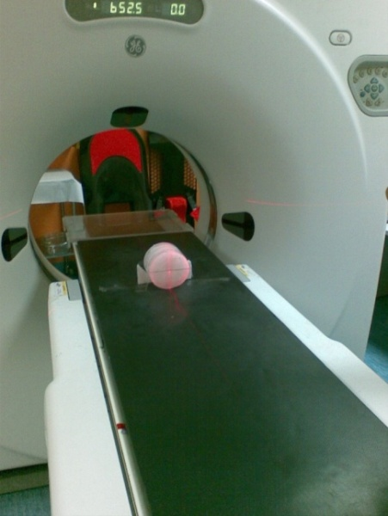

Fig. 1. XCT scan of the phantom.
The picture of the POT system is shown in Fig. 3. We used laser diodes as light sources lasing at 635 nm, 784 nm as well as “green” laser operating at 532 nm. A polarizer, a quarter-wave plate and a half-wave plate were applied in front of the phantom in order to change the Stokes vector of the illuminating laser beam. In front of photo-detector we put only quarter-wave plate and polarizer for intensity measurements of the scattered light required for calculations of the output Stokes vector elements and next for calculations of the Mueller matrix elements of the breast phantom. A computer has controlled angular movement of the turntable with the phantom as well as is used for collection of the data from the photo-detector.

Green light was used only to test the POT system because paraffin and INTRALIPIDTM have extremely high absorption coefficients in this region of light spectrum. Infrared and red light give different result of imaging and would be particularly useful for tests of phantoms with inclusions consisted of blood with different levels of oxygen saturation.

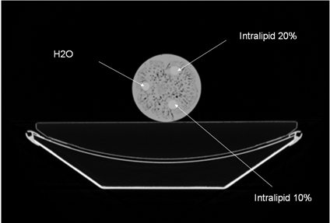
Fig. 2. Reconstructed X-ray computed tomography image of the phantom.
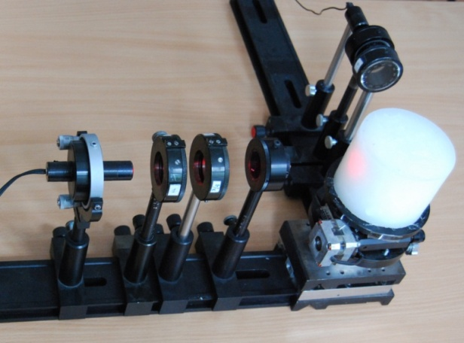
Fig. 3. The polarimetric optical tomography system consist of light source, polarization state generator, phantom on rotating table, polarization state analyser and detector.
We can see polar graph of one of the Mueller matrix element. The angle corresponds to the phantom position of the measuring system. Maxima of this function indicate the position of inclusions. The values of these maxima depend on polarization properties of scattering media in inclusions. The true positions of IntralipidTM inclusions are shown as well. We can see that angular positions of inclusions shown by POT method has low accuracy but allow to differentiate the densities of 10% and 20% INTRALIPIDTM inside paraffin which is very high scattering medium for light.
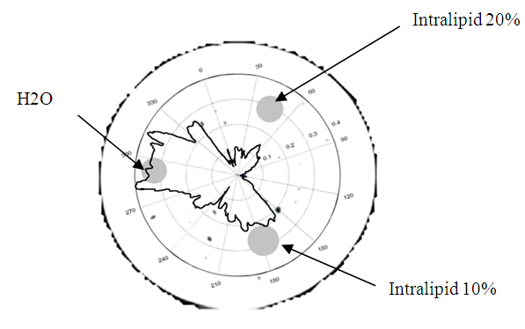
Fig. 4. Comparison between results of Computed Tomography
and Polarimetric Optical Tomography imaging
Simultaneous analysis of both imaging systems i.e. XCT and POT may allow not only for exact location of the inclusions but also help to determine their character. Further tests with a new phantom as well as an improved measurement system allowing for higher accuracy are planned in the future. We believe that POT system may be an additional diagnostic tool for X-ray mammography helping to differentiate breast tumor types.
Acknowledgments
The work leading to the paper was supported by the Polish Ministry of Science and Education under the grant No N N518 385237.

References

- Stanton L., Villafana T., Day J. L. and Lightfoot D. A., "A breast phantom method for evaluating mammography technique", Invest Radiol. Vol. 13, No. 4, (1978 )
- Obenauer S., Hermann K. P. and Grabbe E., "Dose reduction in full-field digital mammography an anthropomorphic breast phantom study", Br J Radiol Vol. 76, No. 907, (2003)
- F. A. R. Silva, L. F. Souza, C. E. G. Salmon and D. N. Suoza, "Breast phantom with silicone implant for evaluation in conventional mammography", JACMP, Vol. 12, No. 1 (2011)
- M. Yakabe, S. Sakai, H. Yabuuchi, Y. Matsuo, T. Kamitani, T. Setoguchi, M. Cho, M. Masuda, and M. Sasaki, "Effect of Dose Reduction on the Ability of Digital Mammography to Detect Simulated Microcalcifications", J. Digit. Imaging, Vol. 23 No.5, (2010)
- E.B. Haller, "Time-resolved transillumination and optical tomography",
J. Biomed. Opt., Vol. 1, No. 1, (1996)
- Tarvainen, T., Vauhkonen, M., Kolehmainen,V., Kaipio, J. P. and Arridge S. R., „Utilizing the Radiative Transfer Equation in Optical Tomography”, PIERS Online, Vol. 4, No. 6, (2008)
- Huang, D. E., Swanson, A. C., Lin, P., Schuman, J. S., Stinson, W. G., Chang, W. M., Hee, R., Flotte, Gregory, T. K., Puliafito, C. A. and Fujimoto, J. G., „Optical coherent tomography”, Science 254, (1991)
- Fercher, A. F., Drexler , W., Hitzenberger, C. K. and Lasser, T., „Optical coherence tomography—principles and applications”, Rep. Prog. Phys. 66, (2003)
- Bajraszewski, T., Gorczyńska, I., Szkulmowska, A., Szkulmowski, M., Targowski P. and Kowalczyk, A. „Spectral Optical Coherence Tomography in ophthalmology”, Proceedings of SPIE 5959, (2005)
- Nielsen, T., Brendel, B., Ziegler, R., Beek, M., Uhlemann, F., Bontus, C. and Koehler, T., „Linear image reconstruction for a diffuse optical mammography system in a noncompressed geometry using scattering fluid”, Applied Optics, Vol. 48, No. 10, (2009)
- P. Sawosz, M. Kacprzak, N. Zolek, W. Weigl, S. Wojtkiewicz, R. Maniewski, A. Liebert, "Optical system based on time-gated, intensified charge-coupled device camera for brain imaging studies", J. Biomed. Opt., Vol. 15, No. 6, (2010)
- S. Srinivasan, B. W. Pogue, H. Dehghani, S. Jiang, X. Song, K. D. Paulsen, "Improved quantification of small objects in near-infrared diffuse optical tomography", J. Biomed. Opt., Vol. 9, No. 6, (2004)
- Hielscher, A. H., Klose, A. D. and Hanson, K. M., „Gradient-Based Iterative Image Reconstruction Scheme for Time-Resolved Optical Tomography IEEE Transactions on Medical Imaging”, Vol. 18, No. 3, (1999)
- J. C. Hebden, B. D. Price, A. D. Gibson and G. Royle, "A soft deformable tissue-equivalent phantom for diffuse optical tomography", Phys. Med. Biol., Vol. 51, (2006)
- Ghosh, N., Woods,M. F. G., Li, S. H., Weisel, R. D. and Wilson, B. C., L. Ren-Ke, I. A. Vitkin, „Mueller matrix decomposition for polarized light assessment of biological tissue”, Journal of Biophotonics, Vol. 2, No. 3, (2009)
- Domanski, A. W., Rytel, M. and Wolinski, T. R., „Polarization optical tomography based on analysis of Mueller matrix elements of scattered light”, Proceedings of SPIE Vol. 5959, (2005)
- S. Miernicki, P. K. Sobotka, A. W. Domański “Comparison of polarization and polarimetric optical tomography methods for recognition of tissue simulators inside breast phantom”, Phot. Lett. Poland, Vol. 3, No 4 (2011)
- M. Born, E. Wolf, “Principles of Optics: Electromagnetic Theory of Propagation, Interference and Diffraction of Light”, 6th ed., (1997)
- Xu, T., Zhang C., Wang X., Zhang L. and Tian J., „Measurement and analysis of light distribution in intralipid-10% at 650 nm”, Applied Optics, Vol. 42, No. 28, (2003).
- S.T. Flock, S.L. Jacques, B.C. Wilson, W.M. Star, M.J.C. van Gemert, „Optical Properties of Intralipid: A phantom medium for light propagation studies”, Lasers in Surgery and Medicine, vol. 12, pp. 510-519, (1992)

